AI-Integrated Capstone Metadata Repository with Intelligent Search and Chatbot Assistance for CTU - Daanbantayan Campus Library

A Capstone Project
Presented to
The Faculty of the Undergraduate School
CEBU TECHNOLOGICAL UNIVERSITY
DAANBANTAYAN CAMPUS
Agujo, Daanbantayan, Cebu, Philippines

In Partial Fulfillment
of the Requirements for the Subject
PC 329 CAPSTONE PROJECT AND RESEARCH 1
BACHELOR OF SCIENCE IN INFORMATION TECHNOLOGY

By:
CABARDO, CARMELA M.
CADARO, JOHN P.
CONDE, CHRISTINE D.
DE JESUS, ALLAN JR. P.
OMPOY, RHEINA C.
APPROVAL SHEET
This CAPSTONE PROJECT AND RESEARCH entitled “AI-Integrated Capstone Metadata Repository with Intelligent Search and Chatbot Assistance for CTU - Daanbantayan Campus Library” is prepared and submitted by CARMELA CABARDO, JOHN CADARO, CHRISTINE CONDE, ALLAN DE JESUS, RHEINA OMPOY in partial fulfillment of the requirements for the degree BACHELOR OF SCIENCE IN INFORMATION TECHNOLOGY, A.Y. 2026-2027 has been examined and is recommended for acceptance and the approval for ORAL EXAMINITION.

ACKNOWLEDGEMENT

Asdasdsadasds

ABSTRACT

We the optimospraym

TABLE OF CONTENTS

TITLE PAGES
TITLE PAGE ………………………………………………………………………… I
APPROVAL SHEET ………………………………………………………………... II
ACKNOWLEDGEMENT …………………………………………………………… III
ABSTRACT …………………………………………………………………………. IV
TABLE OF CONTENTS …………………………………………………………… V

CHAPTER 1

Chapter 1

THE PROBLEM AND ITS SCOPE

INTRODUCTION

Rationale of the Project
- Project Information
Academic libraries are essential for preserving academic study outputs like capstone projects, which serve as critical references for future students [11]. However, the CTU Daanbantayan Campus Library currently lacks a web-based method and essential functionality about easy to find and less effort in finding or searching. For student needs specifically when finding relevant study and ideas, this is not an easy task to do. This results in poor discoverability, inefficient retrieval, and a higher risk of students proposing redundant research topics due to difficulty in accessing previous work.

To address this, we propose an AI-Integrated Capstone Metadata Repository. This web-based platform will store key project metadata such as titles, authors, abstracts, and suggested future research, but not the full project files. The system will feature two core AI functionalities: an intelligent search with advanced filtering for precise discovery, and an AI-powered chatbot to guide users and answer queries. This approach promotes accessible and reusable research data [12]. Recent studies confirm that AI is transforming library services by enhancing resource discovery, streamlining operations, and improving user engagement [13]. The repository will serve students seeking research ideas, advisers validating project titles, and librarians managing institutional knowledge.

- Project Objectives
This project aims to develop a functional web-based repository for the CTU Daanbantayan Campus Library with the following specific objectives:

- Develop a Secure User System: Implement role-based access control (for students, advisers, librarians) to ensure data security and proper authorization, a standard practice in web-based project management [14].
- Create an Archival Module: Systematically store capstone metadata to build a durable and accessible institutional memory, similar to successful research platforms like Zenodo [15].
- Build an Intelligent Search Mechanism: Enable users to quickly locate relevant projects using filters like keywords, author, and year, addressing the core challenge of research discoverability [16].
- Integrate an AI Chatbot Assistant: Deploy a chatbot to provide real-time guidance and answer system confusion in the system, leveraging natural language processing to enhance the user experience [17].
- Construct an Administrative Dashboard: Empower librarians with a tool to efficiently upload, update, and manage project records [18].

- Significance
Academic Significance:
For students, the repository simplifies topic identification and helps ensure the originality of their research by making previous work easily discoverable [13]. For advisers, it provides a powerful tool to validate new proposals against existing projects and identify research trends. For the institution, it fosters a stronger research culture by preserving student work and making it accessible for future generations, adhering to the FAIR principles (Findable, Accessible, Interoperable, Reusable) [12]. For librarians, it streamlines cataloging and reduces administrative burden, allowing them to focus on higher-level support [16].

Industry Significance:
The project demonstrates a practical, scalable application of AI in education, serving as a model for digital transformation in resource-constrained settings [17]. It equips students with hands-on experience in web development and AI integration, building skills directly relevant to the technology sector. Furthermore, it contributes to the growing body of knowledge on AI adoption in academic libraries, a field experiencing exponential research growth [13].

- Conclusion and Recommendation
The AI-Integrated Capstone Metadata Repository is a necessary innovation to solve critical issues of research discoverability and knowledge preservation at the CTU Daanbantayan Campus Library. By leveraging AI for intelligent search and user support, the system will transform how the academic community interacts with past research, ultimately strengthening the university's research culture [11] [13].

It is recommended that the library proceed with this project, with a focus on:
- Phased Implementation: Start with core archival and search functions before adding the AI chatbot [15].
- Stakeholder Engagement: Consult with end-users (students, faculty, librarians) during design [13].
- Sustainability Planning: Establish clear protocols for data migration, staff training, and long-term system maintenance to ensure the repository remains a valuable asset for years to come [12] [19].

Technical Background
This section establishes the technical feasibility of the proposed AI-Integrated Capstone Metadata Repository by showing how the project directly applies knowledge from previous BSIT courses and uses proven, open-source technologies.

- Knowledge from Previous BSIT Courses
The proponents apply competencies gained from the following subjects already completed:

- Web Systems and Technologies and Object-Oriented Programming – for planning a responsive web platform with user authentication and role-based access control.
- Information Management and Database Systems – for designing metadata organization and efficient storage/retrieval structures.
- Computer Programming 1 & 2 – for implementing search logic, filtering mechanisms, and API integration.
- Networking – for planning secure HTTPS connections and cloud-based deployment.

These courses provide all the foundational skills needed to design the system without requiring new technical knowledge.

- Review of Existing Solutions and Technologies
The current CTU Daanbantayan Campus Library still relies on physical copies and basic digital folders, resulting in poor searchability and duplicated research efforts.

Literature and successful implementations confirm that this problem is best solved through metadata repositories combined with AI tools:
- Institutional repositories such as Zenodo have proven the effectiveness of metadata storage for preservation and discoverability.
- The FAIR principles (Findable, Accessible, Interoperable, Reusable) serve as the standard for research data management.
- Recent studies show that AI-powered intelligent search and chatbots greatly improve library user experience and resource discovery.
- Role-based access control (RBAC) is the established method for securing academic systems.

- Planned Tools, Frameworks, and Techniques
The following tools and approaches will be used:
- Web technologies: HTML, CSS, JavaScript, and a modern front-end framework for the user interface.
- Cloud platform: Firebase Cloud Hosting with Firebase Firestore for secure, scalable, and real-time database operations.
- Intelligent search: Open-source Meilisearch (MIT-licensed). The system will not develop the search engine from scratch; instead, capstone metadata will be indexed into Meilisearch to provide fast, typo-tolerant, filtered, and semantic search via its ready-made API and SDKs.
- AI chatbot: External AI APIs (e.g., Google Gemini, Mistral, Cerebras, and groq) for natural language processing and real-time user guidance.
- Security: Firebase Authentication with role-based access control for students, advisers, and librarians.
All selected tools are free or low-cost for academic use, compatible with the proponents’ existing skills, and appropriate for a campus-scale repository. Meilisearch will be properly cited as the official open-source reference.

- Technical Constraints and Feasibility
The repository will store only metadata (title, authors, adviser, year, abstract, and citation) and will not include full capstone files. Uploading and editing will be restricted to administrators (librarians). AI features require internet connectivity and external APIs. The system will cover only the Daanbantayan Campus.

These constraints keep the project realistic and manageable within the two-semester capstone timeline. With the knowledge from prior courses and the use of proven open-source technologies, the proposed system is technically feasible and ready for full development in Capstone 2.

REVIEW OF RELATED SYSTEMS

Recent advancements in artificial intelligence have significantly influenced the development of intelligent information systems, particularly in academic environments. According to Adamopoulou and Moussiades (2022) [1], AI-powered chatbots simulate human conversation and provide real-time automated responses, making them effective tools for user interaction. Similarly, Lin et al. (2022) [9] emphasized that conversational AI systems are scalable and capable of improving user engagement. In the context of academic libraries, Ehrenpreis and DeLooper (2021) [2] found that chatbot integration enhances user experience by assisting in navigation and information retrieval.
While these studies establish the importance of chatbots, recent research highlights that chatbot effectiveness depends on how it is integrated with a knowledge source. Lewis et al. (2020) [6] introduced Retrieval-Augmented Generation (RAG), which combines information retrieval with language generation to produce context-aware responses. This approach is particularly relevant for the proposed system, where the chatbot will rely on stored capstone metadata instead of generating answers independently. In this study, external free AI APIs (e.g., Gemini, and Mistral) will be utilized, meaning the focus is not on building the model itself but on integrating it effectively within a web-based environment through API calls and prompt structuring.
In terms of search functionality, traditional keyword-based search methods have limitations in understanding user intent. Reimers and Gurevych (2019) [7] addressed this limitation through “Sentence-BERT”, which enables semantic search by interpreting the contextual meaning of queries. Compared to basic SQL “LIKE” queries, semantic search improves accuracy by matching intent rather than exact words. This justifies the use of Meilisearch in the proposed system, as it provides built-in support for fast indexing, typo tolerance, and relevance ranking, making it more suitable for a campus-scale repository than conventional database search methods.
Furthermore, metadata plays a critical role in organizing academic repositories. He and Garcia-Molina (2021) [3] explained that metadata-driven systems improve data retrieval by structuring information for efficient indexing. The FAIR principles (Wilkinson et al., 2016) [12] further support this approach by promoting data that is Findable, Accessible, Interoperable, and Reusable. In practical implementation, this will be reflected in the Firestore database structure, where each capstone entry will include standardized fields such as title, author, abstract, and keywords to support efficient filtering and searching.
Security is also a key consideration in web-based systems. Sandhu et al. (1996) [14] introduced Role-Based Access Control (RBAC), which restricts system access based on user roles. This model is widely used in modern applications and will be implemented using Firebase Authentication to ensure that only authorized users (e.g., librarians) can manage repository data. Compared to traditional session-based authentication, Firebase provides a more scalable and secure cloud-based solution suitable for distributed users.
In addition to literature, existing systems also demonstrate the effectiveness of digital repositories. Platforms such as Zenodo [15] provide open-access storage for research outputs, proving that centralized repositories improve accessibility and preservation. However, these systems lack integrated AI-based assistance tailored to specific institutional needs. Unlike Zenodo, the proposed system focuses on localized academic content and incorporates intelligent search and chatbot assistance specifically designed for CTU–Daanbantayan Campus.
Overall, while previous studies and systems have addressed chatbot interaction, semantic search, and digital repositories individually, there remains a gap in integrating these technologies into a single, user-friendly platform tailored for academic capstone management. The proposed AI-Integrated Capstone Metadata Repository aims to bridge this gap by combining metadata organization, intelligent search, and AI-assisted interaction into one cohesive system.

THE PROBLEM

Statement of the Problem/Objectives of the Project
Despite the growing focus on research and innovation in Cebu Technological University Daanbantayan Campus, the library’s current system for storing and retrieving capstone project documents presents several operational and accessibility issues that make it difficult for students and staff to find and use these studies effectively.
Currently, capstone projects at Cebu Technological University Daanbantayan Campus are mainly stored in physical format or in basic digital folders without proper metadata organization. This traditional approach leads to several critical issues. First, there is no centralized, structured repository that allows for efficient cataloging and retrieval of past capstone projects. Students and faculty members often struggle to locate relevant previous work that could inform their own research, resulting in duplicated efforts and missed opportunities for building upon existing knowledge. Second, the absence of comprehensive metadata makes it nearly impossible to search for projects based on specific criteria such as research topic, methodology, year, program, or keywords, severely limiting the discoverability of valuable academic work.
The study aims to address the lack of a centralized, unorganized, time-consuming methods of accessing physical copies and to implement an AI-Integrated Capstone Metadata Repository with Intelligent Search and Chatbot Assistance for CTU - Daanbantayan Campus Library effective for handling of capstone project information's.
These are the following questions that are need to address:
1. What is the existing condition of capstone project management at CTU Daanbantayan Campus Library in terms of:
1.1 Capstone project storage and archiving;
1.2 Accessibility and retrieval at research documents;
1.3 Search and indexing mechanisms
1.4 Preservation and management of capstone project
2. Based on the identified needs, to what extent can the proposed system improve the following:
2.1 Metadata organization and repository management
2.2 Search efficiency through intelligence search features
2.3 User support through chatbot assistance; and
2.4 Data security and accessibility of capstone projects?
3. What are the current challenges faced by students and library staff in accessing and managing capstone projects at CTU–Daanbantayan Campus Library?
4. How can metadata organization improve the efficiency and accuracy of retrieving capstone projects?
5. How effective is an AI-powered intelligent search system in helping users find relevant capstone studies?
6. How can chatbot assistance enhance user experience and system navigation within the repository?

Scope and Limitations of the Project
Scope: The study focuses on the development of a web-based capstone metadata project repository designed specifically for the CTU Daanbantayan Campus Library. The system will incorporate intelligent search functionality with filtering options to help users quickly locate relevant research records. In addition, the system will integrate an AI-powered chatbot assistant that will guide users in navigating the system. The repository will store essential information about each capstone metadata project, including the project title, authors, adviser, year of completion, abstract and citation details. The system will serve several categories of users. Direct users include students, research advisers, and future researchers who wish to explore previous capstone studies. Indirect users include university administrators, and program coordinators or department heads.
LIMITATION: The system has several content-related limitations. It will display only several project information such as titles, authors, advisers, year completed, and abstracts. Full capstone metadata project files will not be included in the system. Additionally, the platform will function as a view-only repository for most users, and editing or uploading project records will require administrator access, typically managed by the librarian. The repository will also include only capstone metadata projects from the CTU Daanbantayan Campus and will not cover capstone outputs from other CTU campuses. Operational limitations may also exist. Since capstone records will be digitally uploaded manually by administrator, delays in posting new projects may occur. Furthermore, author contact information may become outdated over time, and the system will require continuous maintenance and updates to remain effective. The AI features of the platform will depend on internet connectivity and the availability of external APIs. User-related limitations should also be considered. Users will need to independently interpret and adapt the information found in previous research projects, and research continuity may depend on updates from future projects and the availability of the original authors.
Significance of the Study and Project Highlights
The proposed system aims to help students identify unique research ideas, assist advisers in validating proposed capstone titles, and improve access to previous capstone metadata projects. It will enable faster discovery of research topics, improve the organization of capstone records, support the long-term preservation of student research outputs, and enhance the accessibility of academic resources for future researchers. Ultimately, the platform will contribute to strengthening the research system within the university.

Methodology
1. Environment
1.1 Locale
Cebu Technological University - Daanbantayan Campus specifically in campus library. The University offer different type of undergraduate program including the Bachelor of Science in Information Technology (BSIT). The institution is located in the Municipality of Daanbantayan, Province of Cebu, Philippines.

The Campus Library serves as the primary academic resource center for students and faculty members. The library is responsible for storing, organizing, and providing access to academic material such as books, journals, and capstone project documents. Library utilizes physical storage and limited digital means (e.g., folders or basic file systems) will lead to inefficiencies in searching, retrieval, and easy way of tracing.

1.2 Population of the Study
The population of the study consists of individuals directly involved in the creation, management, and utilization of capstone project documents at CTU–Daanbantayan Campus. Specifically, the study includes the following groups:
Students (Primary Users)
These include BSIT students, particularly those in their 3rd and 4th year levels who are actively engaged in capstone project development. Students are the primary beneficiaries of the system as they frequently access previous capstone studies for reference, topic validation, and research guidance.
Faculty Advisers
Faculty members who serve as project advisers play a critical role in validating capstone proposals and ensuring originality of research topics. They require access to previous capstone metadata to evaluate duplication and relevance of proposed studies.
Library Personnel (Administrators)
Librarians and library staff are responsible for managing, organizing, and maintaining capstone project records. In the proposed system, they will act as administrators who handle data entry, updates, and system monitoring through an administrative dashboard.

The respondents for data gathering are selected using purposive sampling, focusing on individuals who have direct experience with the current capstone project management system. Surveys and evaluations will be conducted among students and library staff to assess existing challenges and measure the effectiveness of the proposed system.

1.3 Organizational Chart/Profile
The organizational structure relevant to this study focuses on the academic and administrative hierarchy involved in capstone project management and library operations at CTU–Daanbantayan Campus.

At the top of the structure is the Campus Administration, headed by the Campus Director, who oversees all academic and administrative functions of the institution. Under the administration are the different academic departments, including the Information Technology Department, which supervises capstone project implementation and academic requirements.

The Library Unit operates as a support service under the campus administration. It is managed by the Head Librarian, who is responsible for overall library operations, including resource management, cataloguing, and user services. Supporting the head librarian are library staff who assist in organizing materials and providing services to students and faculty.

In relation to the capstone project process, faculty advisers coordinate with students throughout the development of their research, while also indirectly interacting with the library for reference materials. Students serve as both contributors (by producing capstone projects) and users (by accessing past research).

The simplified organizational structure is as follows:

Campus Director
└── Academic Departments (e.g., IT Department)
└── Faculty Advisers
└── Students (Capstone Researchers)
└── Library Unit
└── Head Librarian
└── Library Staff

This organizational setup highlights the interaction between students, faculty, and library personnel, which the proposed system aims to enhance by providing a centralized, accessible, and intelligent repository for capstone metadata.

2. Requirements Specifications
2.1 Operational Feasibility
2.1.1 Fishbone Diagram
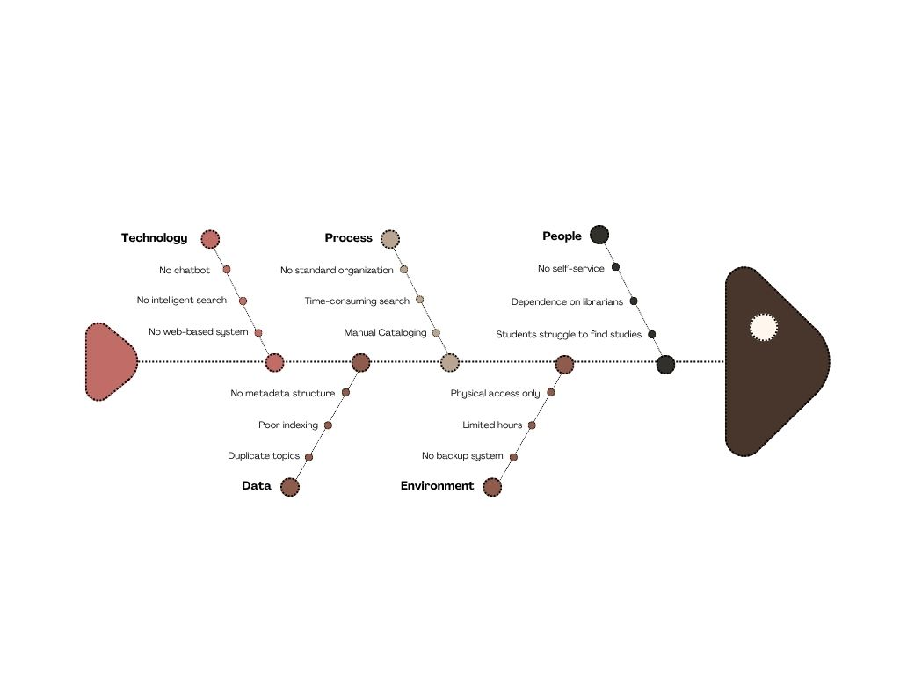
The Fishbone Diagram illustrates the root causes of the challenges in accessing and managing capstone projects at CTU – Daanbantayan Campus Library, categorized into people, process, technology, data, and environment. These include reliance on manual processes, lack of a centralized digital system, absence of intelligent search and chatbot features, poor metadata organization, and limited accessibility due to physical constraints.
Such issues result in inefficient retrieval, poor research discoverability, and increased chances of duplicated topics. The diagram highlights the need for a centralized, AI-integrated repository system to improve access, organization, and overall user experience.
2.1.2 Functional Decomposition Diagram
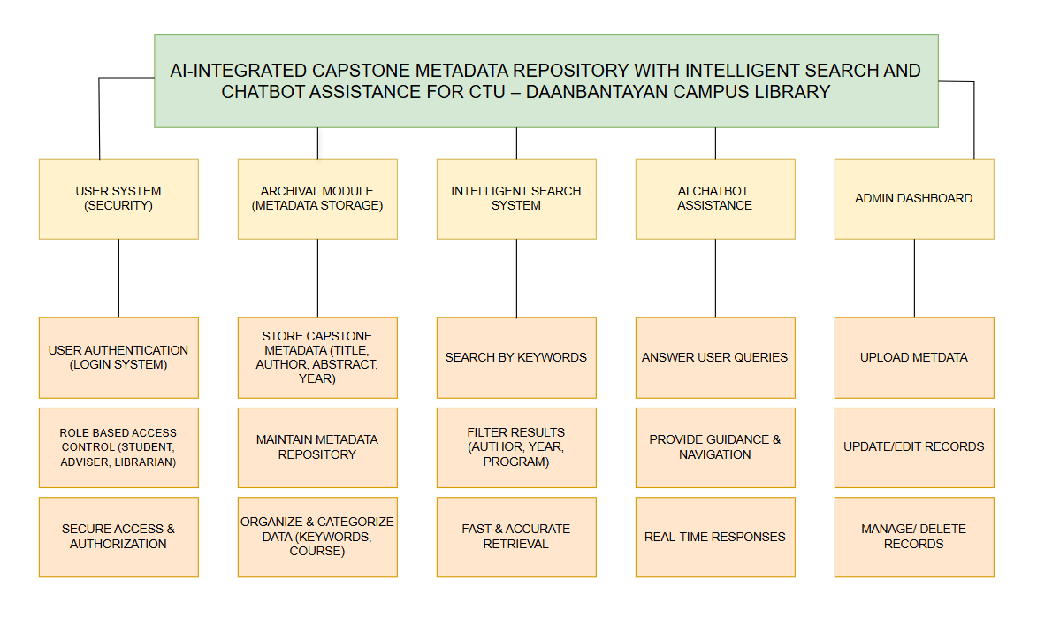

The diagram shows how the main functions of the system are combined into a single web-based platform for managing capstone project metadata at the CTU–Daanbantayan Campus Library. It includes an archival module that stores structured information such as title, author, abstract, year, and keywords, making it easier to organize, access, and preserve academic records. This centralized approach addresses the current problem of having no proper system for storing and retrieving capstone information. The system also improves research discovery through an intelligent search feature that allows users to search using keywords and apply filters like author, year, and program, helping them quickly find relevant studies and avoid duplication of research topics.
In addition, the system integrates an AI chatbot that provides real-time assistance by answering user questions and guiding them through the platform, making it more user-friendly and reducing the need for manual support from library staff. It also includes a secure user management system with role-based access control to ensure that students, advisers, and librarians have appropriate permissions. An administrative dashboard allows librarians to upload, update, and manage capstone metadata efficiently, ensuring that the information remains accurate and reliable. Overall, the diagram highlights how the system improves accessibility, efficiency, and organization of capstone project information while supporting better research practices.

2.2 Technical Feasibility
The proposed AI-Integrated Capstone Metadata Repository with Intelligent Search and Chatbot Assistance is considered technically feasible due to the availability of modern web technologies, database systems, and artificial intelligence tools that support the development and deployment of the system.
The system will be developed as a web-based application, utilizing standard and widely adopted technologies such as HTML, CSS, and JavaScript for the front-end interface, and a server-side programming language such as PHP or Node.js for backend processing. These technologies are well-documented, scalable, and appropriate for building interactive and data-driven systems in an academic environment.
The database component of the system will utilize Google Firebase Firestore, a cloud-based NoSQL database that supports flexible and scalable data storage. Since the system is designed to store only metadata including titles, authors, abstracts, keywords, and suggested future research and not full-text documents, the storage requirements are minimal and manageable. This design choice improves system performance, simplifies data management through its document-based structure, and supports faster data retrieval, addressing the current issues of poor organization and inefficient retrieval identified in the existing system.
From a hardware and software perspective, the system does not require specialized or high-end resources. Development can be conducted using standard personal computers, and deployment will be carried out through Firebase’s cloud-based hosting and backend services. Required software tools include code editors or integrated development environments (IDEs), database management systems, and web browsers for testing. This makes the system cost-effective and suitable for implementation within the university setting.
2.3 Schedule Feasibility
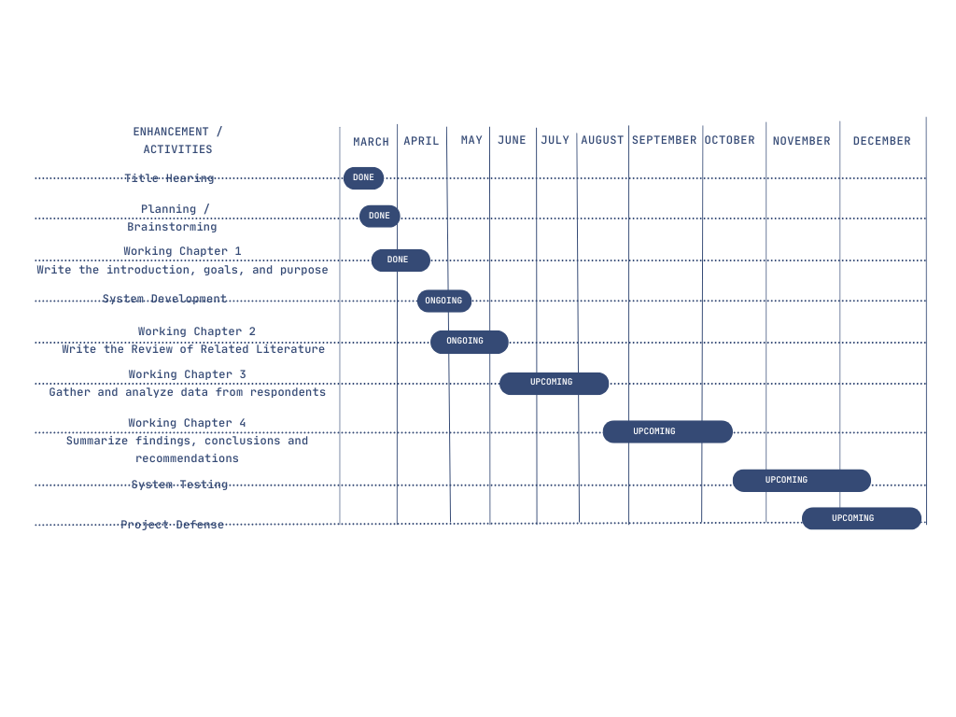
The Gantt chart presents the structured timeline of the study titled AI-Integrated Capstone Project Repository with Intelligent Search and Chatbot Assistance for the Cebu Technological University Daanbantayan Campus Library. It is shown that the preliminary phases, such as the title hearing, project planning, and the preparation of Chapter 1 (introduction, goals, and purpose) have already been accomplished. The project is currently being carried out in the system development stage, wherein the design and development of the proposed system are being undertaken, along with the ongoing preparation of Chapter 2 (Review of Related Literature).
Subsequent phases are scheduled to be conducted, including data gathering and analysis, the completion of the remaining chapters, and system testing to ensure functionality and effectiveness. Finally, the study is expected to be culminated through the project defense, where the system and research outcomes will be formally presented and evaluated.

3. Requirements Modeling
3.1 Input-Process-Output Diagram
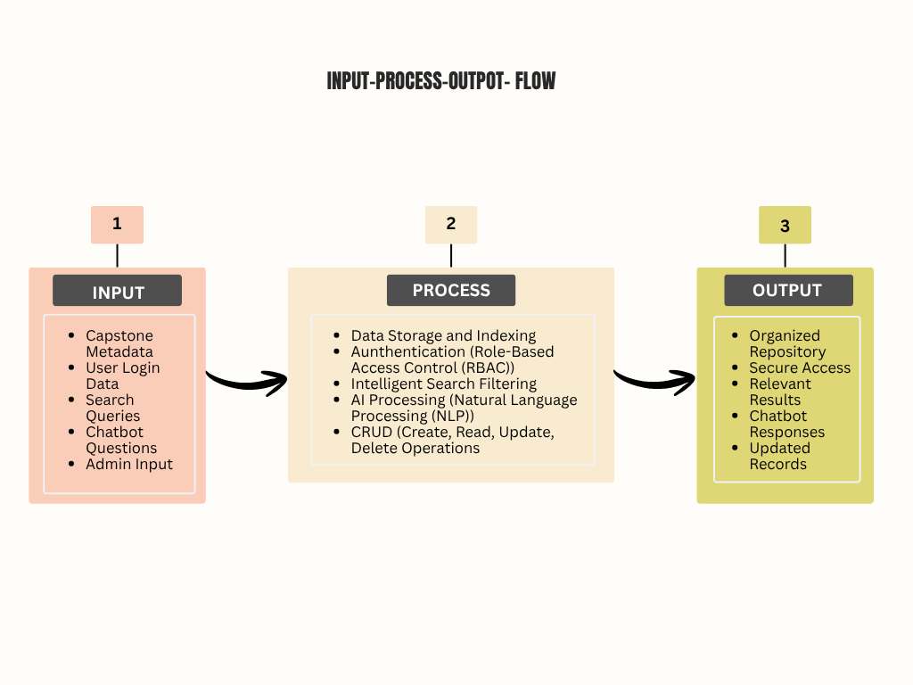

The Input-Process-Output (IPO) model of the proposed AI-Integrated Capstone Metadata Repository with Intelligent Search and Chatbot Assistance for CTU – Daanbantayan Campus Library. The process begins with the input of essential data such as capstone project metadata (including title, authors, adviser, year, abstract, and keywords), user credentials for students, advisers, and librarians, search queries, and administrative inputs for managing records. Additionally, user questions directed to the AI chatbot and system resources such as the database, search engine, and AI APIs are included as part of the input.
These inputs are processed through a series of system operations, including user authentication and role-based access control to ensure security, data storage and organization within the database, and indexing of metadata into an intelligent search engine for efficient retrieval. The system also processes user queries using advanced filtering and matching techniques, while the AI chatbot utilizes Natural Language Processing (NLP) to understand and respond to user questions. Administrative functions such as adding, updating, and deleting records are also performed during this stage, along with validation and security checks.
As a result, the system produces outputs such as accurately filtered and relevant capstone project results, real-time chatbot responses that guide users, and confirmation messages for system actions. Ultimately, the output is a well-organized, accessible, and efficient digital repository that improves research discoverability, reduces the time and effort required to find relevant studies, and enhances the overall user experience for students, advisers, and librarians.

3.2 Data and Process Modeling
3.2.1 Context Diagram
The Context Diagram presents the overall interaction between the proposed system and its external entities. The AI-Integrated Capstone Metadata Repository with Intelligent Search and Chatbot Assistance is represented as a single process, interacting with Students and Library Personnel (Administrators).
Students use the system to search for capstone metadata and receive chatbot assistance, while library personnel manage the system by inputting, updating, and maintaining capstone records. The diagram defines the system boundary and shows how data flows between the users and the system.
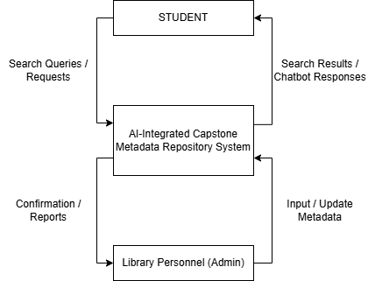

3.2.2 Data Flow Diagram
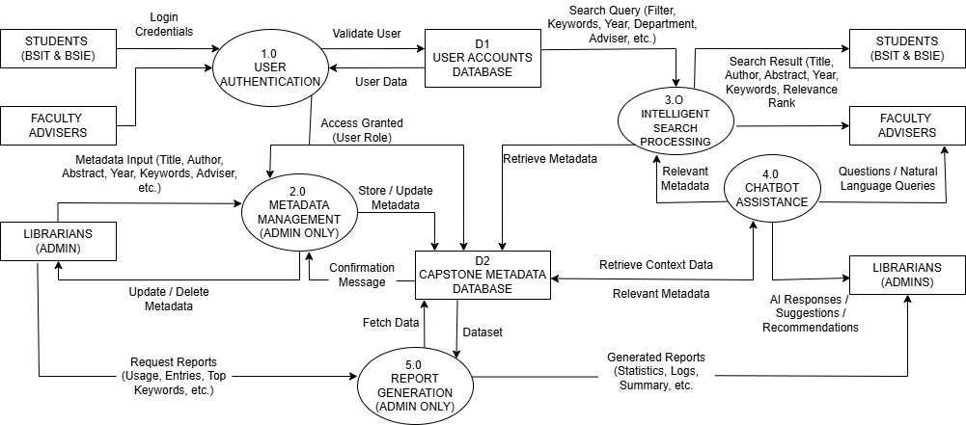
3.2.3 System Flowchart
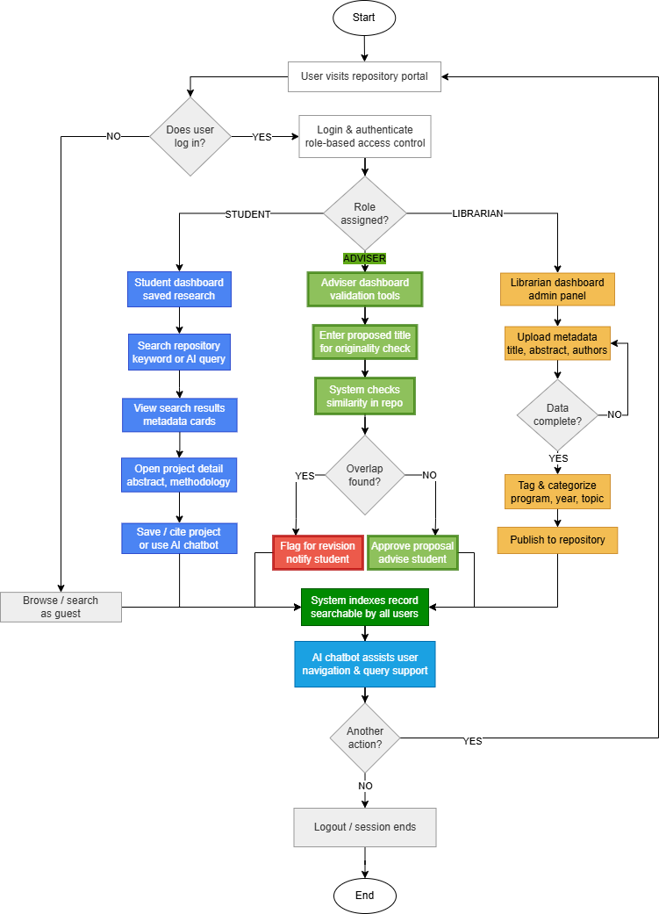
3.2.4 Program Flowchart
- User Login with Role-Based Access Control
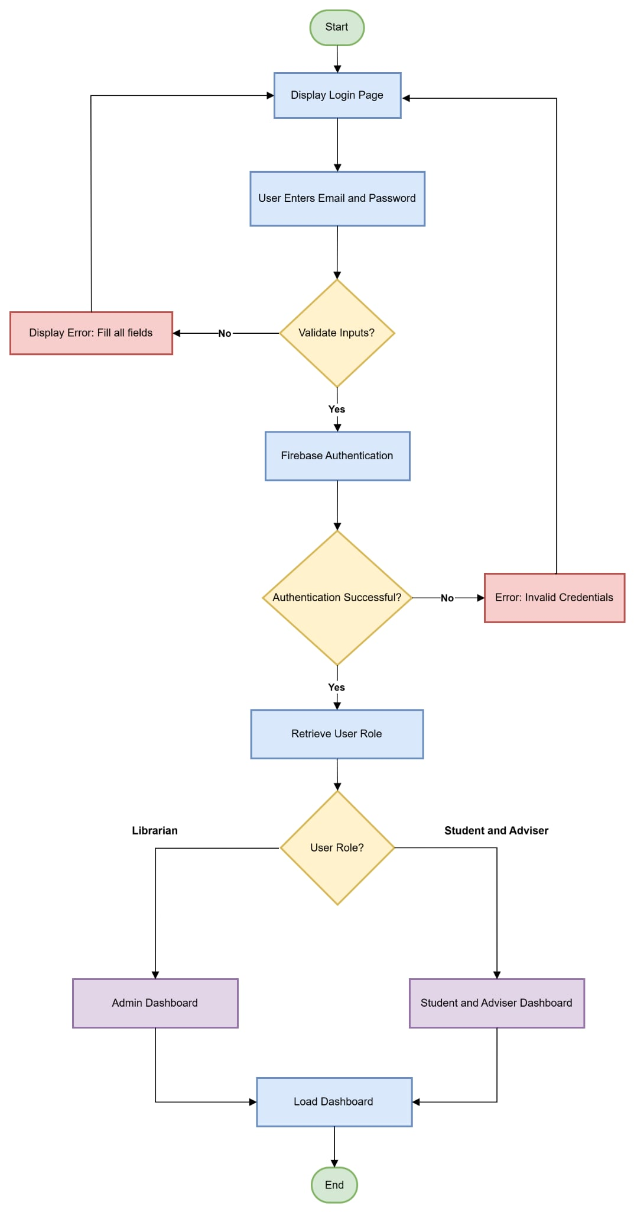
The User Authentication and Role-Based Access Control Module serves as the security foundation of the AI-Integrated Capstone Metadata Repository. This module handles user login through Firebase Authentication and implements Role-Based Access Control (RBAC) to ensure that only authorized users can access specific system features. Upon successful authentication, the system determines the user’s role—Student, Adviser, or Librarian—and redirects them to their respective dashboards. This mechanism protects sensitive administrative functions while providing appropriate access levels to different user types, thereby maintaining data integrity and system security.

- Intelligent Search Module
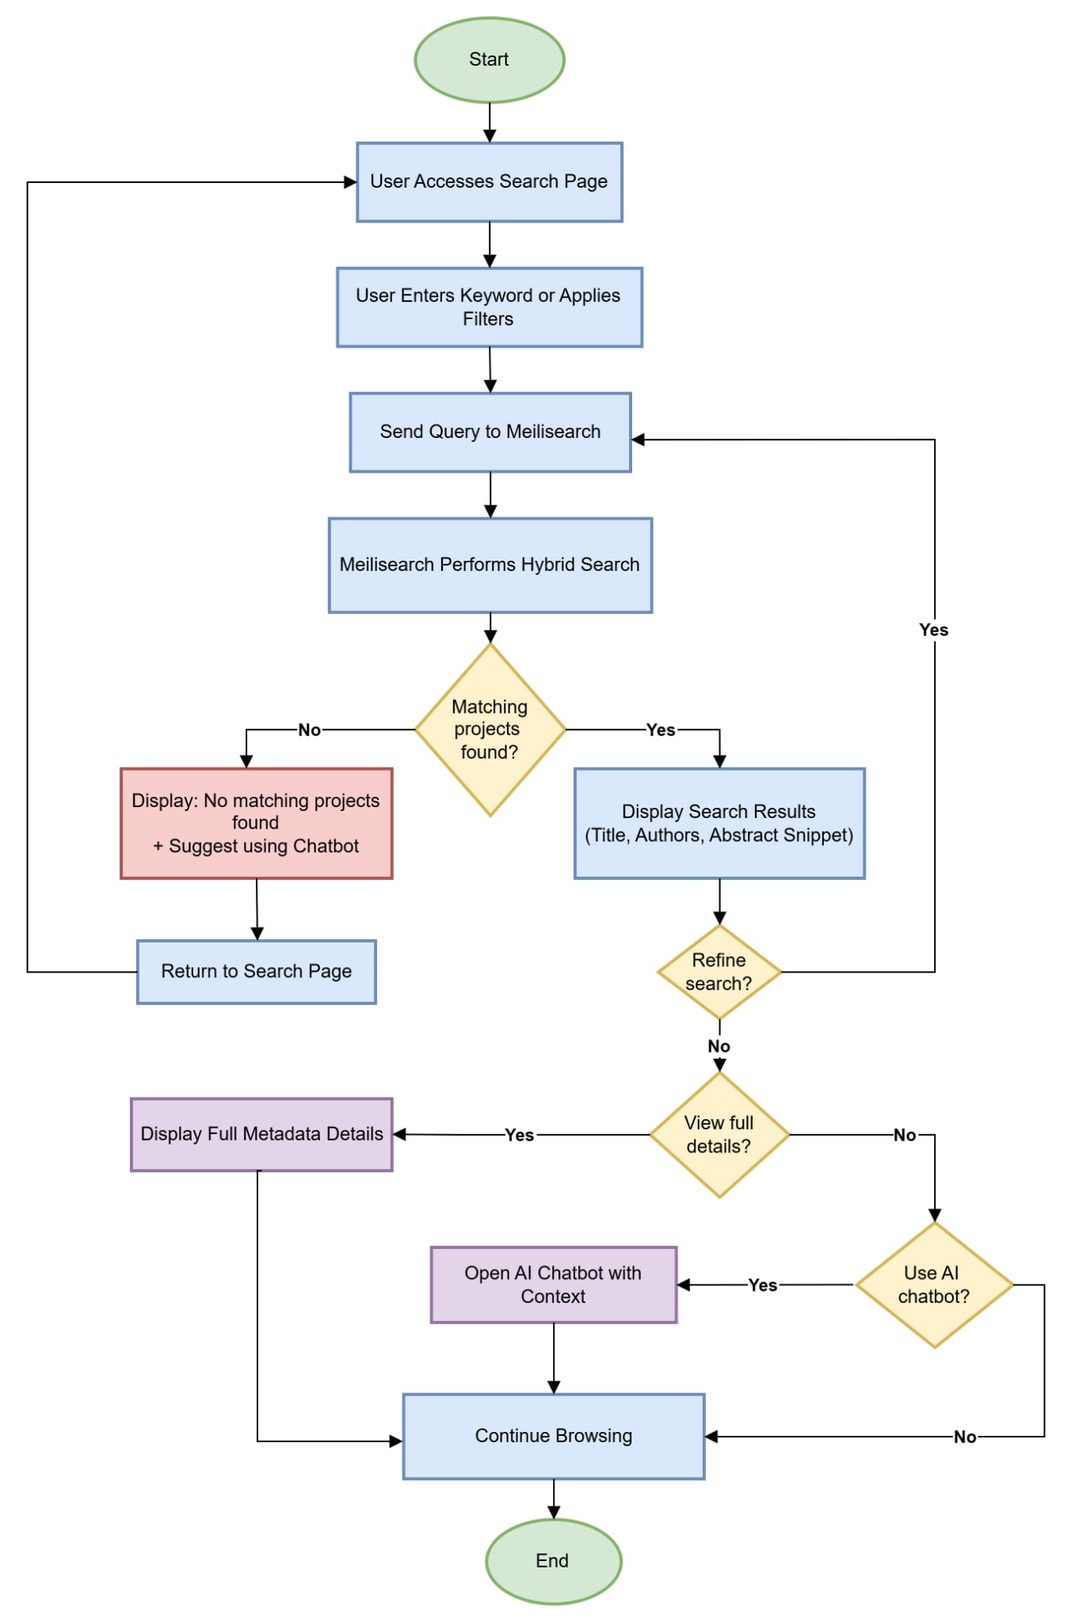
The Intelligent Search Module is the core functionality of the proposed system, designed to address the limitations of traditional keyword-based searching. This module utilizes Meilisearch, an open-source search engine, to provide fast, typo-tolerant, and semantically aware search capabilities. Users can search capstone metadata using keywords, filters such as author, year, program, and title. The module processes user queries through Meilisearch’s hybrid search functionality, ranks results by relevance, and displays essential metadata including title, authors, abstract snippets, and year. This significantly improves the discoverability and retrieval efficiency of capstone projects compared to conventional manual or basic database search methods.

- AI Chatbot Assistance Module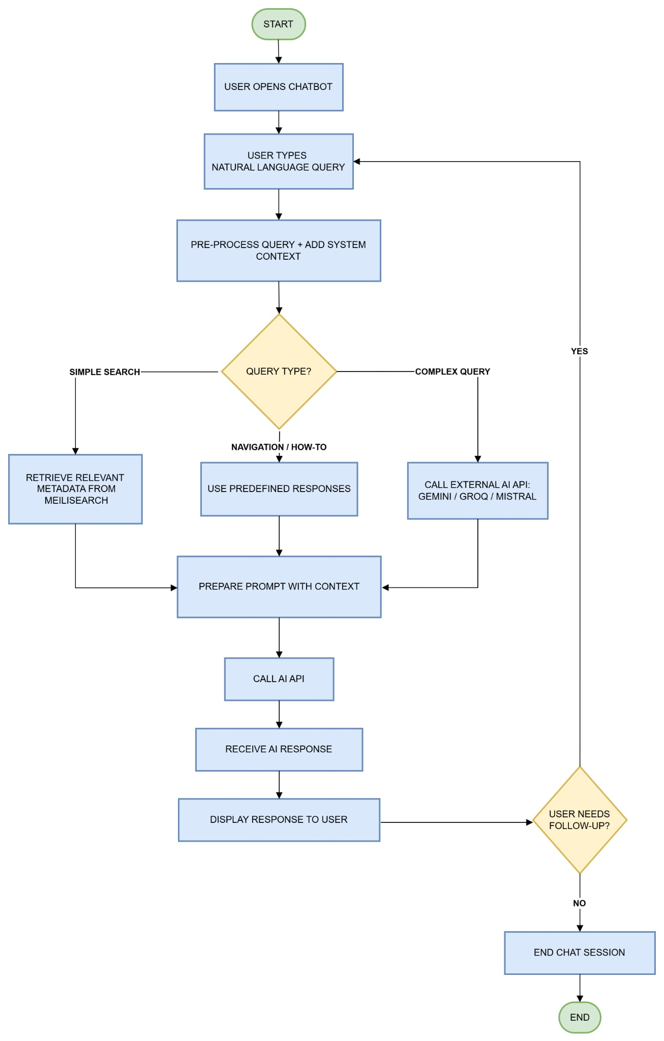
The AI Chatbot Assistance Module enhances user experience by providing real-time, intelligent support within the repository. Powered by external AI APIs such as Google Gemini, Groq, or Mistral, the chatbot employs natural language processing to understand user queries. It utilizes a Retrieval-Augmented Generation (RAG) approach by retrieving relevant capstone metadata from Meilisearch to generate context-aware responses. The module assists users in navigating the system, answering queries about specific projects, suggesting search improvements, and providing general guidance. This feature reduces dependency on library staff and offers 24/7 assistance to students and faculty members.

4. Analysis
4.1 Cost and Benefit Analysis (for projects that entails monetary costs)
4.2 Cost Recovery Scheme (for projects that entails monetary costs)
4.3 Risk Assessment/Analysis
5. Design
5.1 Output and User-Interface Design
5.1.1 Forms
5.1.2 Reports
5.2 Data Design
5.2.1 Entity Relationship Diagram (use MS Access Relationships but not preferable for implementation)
5.2.2 Data Dictionary
5.3 System Architecture
5.3.1 Network Model
5.3.2 Network Topology
5.3.3 Security
6. Development
6.1 Software Specification
6.2 Hardware Specification
6.3 Program Specification
6.4 Programming Environment
6.4.1 Front End
6.4.2 Back End
6.5 Deployment Diagram
6.6 Test Plan
7. Testing
7.1 Unit Testing
7.2 Integration Testing
7.3 System/Alpha Testing
7.4 Acceptance Testing (must be done after the final oral defense)

REFERENCES
[1] Adamopoulou, E., & Moussiades, L. (2022). An overview of chatbot technology. In Artificial Intelligence Applications and Innovations (pp. xx–xx). Springer. https://doi.org/10.1007/978-3-030-49186-4_31
[2] Ehrenpreis, M., & DeLooper, J. (2021). Implementing a chatbot on a library website. Consensus. https://consensus.app/papers/implementing-a-chatbot-on-a-library-website-ehrenpreis-delooper/
[3] He, Y., & Garcia-Molina, H. (2021). Metadata-driven digital repository systems and intelligent search frameworks. Proceedings of the ACM. https://doi.org/10.1145/3450983
[4] Khan, R., Das, A., & Kaur, M. (2022). Build-a-Bot: Transformer-based chatbot system. arXiv. https://arxiv.org/abs/2212.07542
[5] Kumar, P., & Singh, A. (2022). Building a chatbot on a closed domain using RASA. arXiv. https://arxiv.org/abs/2208.06104
[6] Lewis, P., Perez, E., Piktus, A., Petroni, F., Karpukhin, V., Goyal, N., Küttler, H., Lewis, M., Yih, W.-t., Rocktäschel, T., Riedel, S., & Kiela, D. (2020). Retrieval-augmented generation for knowledge-intensive NLP tasks. arXiv. https://arxiv.org/abs/2005.11401
[7] Reimers, N., & Gurevych, I. (2019). Sentence-BERT: Sentence embeddings using Siamese BERT networks. arXiv. https://arxiv.org/abs/1908.10084
[8] Research and Capstone Project Electronic Repository. (2020). Research and capstone project electronic repository. ResearchGate. https://www.researchgate.net/publication/337194832_Research_and_Capstone_Project_Electronic_Repository
[9] Lin, C.-C., Huang, A. Y. Q., & Yang, S. J. H. (2022). A review of AI-driven conversational chatbots. Sustainability, 15(5), 4012. https://doi.org/10.3390/su15054012
[10] Zhang, Y., Li, X., & Wang, H. (2022). AI-driven chatbot integrated with repositories. Mathematics, 10(5), 850. https://doi.org/10.3390/math10050850
[11] C. A. Lynch, “Institutional repositories: Essential infrastructure for scholarship in the digital age,” portal: Libraries and the Academy, vol. 3, no. 2, pp. 327–336, 2003.
[Online]. Available: https://doi.org/10.1353/pla.2003.0039
[12] M. D. Wilkinson et al., “The FAIR guiding principles for scientific data management and stewardship,” Scientific Data, vol. 3, 2016.
[Online]. Available: https://doi.org/10.1038/sdata.2016.18
[13] A. M. Cox, S. Pinfield, and S. Rutter, “The intelligent library: Thought leaders’ views on the likely impact of artificial intelligence on academic libraries,” Library Hi Tech, vol. 37, no. 3, pp. 418–435, 2019.
[Online]. Available: https://doi.org/10.1108/LHT-08-2018-0105
[14] R. S. Sandhu, E. J. Coyne, H. L. Feinstein, and C. E. Youman, “Role-based access control models,” IEEE Computer, vol. 29, no. 2, pp. 38–47, 1996.
[Online]. Available: https://doi.org/10.1109/2.485845
[15] CERN, “Zenodo: Open-access repository,” 2013.
[Online]. Available: https://zenodo.org
[16] Z. D. Muhammad, R. Adamu, S. Abubakar, and K. Ibrahim,
“Application of Artificial Intelligence in Information Retrieval for Academic Research: A Systematic Literature Review Using PRISMA,” Dala Journal of Library and Information Practice, vol. 3, no. 1, June 2025.
[Online]. Available: https://www.researchgate.net/publication/395534477
[17] P. Darshan, E. Sanghavi, G. Chennakeshava, and M. M. Kodabagi,
“AI Chatbot for Educational Institution: A Case Study,” in Proc. 2025 IEEE Int. Conf. on Knowledge Engineering and Communication Systems (ICKECS), 2025.
[Online]. Available: https://www.researchgate.net/publication/392987584
[18] T. W. Araya and A. Mengsteab,
“Designing Web-based Library Management System,” International Journal of Engineering Research & Technology (IJERT), vol. 9, no. 10, 2020.
[Online]. Available: https://www.researchgate.net/publication/344728543
[19] M. Aleedy, E. Atwell, and S. Meshoul,
“Artificial Intelligence (AI) in Education: Using AI Tools for Teachin g and Learning Process,” in Proc. ICSISCET, 2021.
[Online]. Available: https://www.researchgate.net/publication/357447234

APPENDICES

Appendix A – Student Survey Questionnaire

Republic of the Philippines
CEBU TECHNOLOGICAL UNIVERSITY – DAANBANTAYAN CAMPUS
Daanbantayan, Cebu

SURVEY QUESTIONNAIRE
AI-Integrated Capstone Metadata Repository with Intelligent Search
and Chatbot Assistance for CTU – Daanbantayan Campus Library

Dear Respondent,

Good day! We are 3rd-year Bachelor of Science in Information Technology students of CTU – Daanbantayan Campus currently conducting a capstone research study. This survey aims to understand the challenges you experience as a student in accessing and managing capstone projects in the library, and to assess the significance of the system we are proposing.

The proposed system – an AI-Integrated Capstone Metadata Repository – is a web-based platform that will allow students to search for past capstone projects using intelligent search features and get assistance through an AI chatbot, without requiring a physical visit to the library.

Please answer all items honestly based on your actual experiences. Your responses will be treated with STRICT CONFIDENTIALITY and used solely for academic purposes.

RATING SCALE LEGEND:
5 – Strongly Agree (SA)  Fully agrees with the statement | 4 – Agree (A)  Generally agrees with the statement | 3 – Neutral (N)  Neither agrees nor disagrees | 2 – Disagree (D)  Generally disagrees with the statement | 1 – Strongly Disagree (SD)  Completely disagrees with the statement

PART I. STUDENT PROFILE
Direction: Please fill in the blanks or check (✓) the appropriate box.

Name (Optional):
Course:
Year Level: | ☐ 1st Year ☐ 2nd Year ☐ 3rd Year ☐ 4th Year
Sex: | ☐ Male ☐ Female ☐ Prefer not to say
Age:

PART II. CURRENT CHALLENGES IN ACCESSING CAPSTONE PROJECTS
Direction: Based on your personal experience as a student of CTU – Daanbantayan Campus, rate each statement by choosing the option that best reflects your level of agreement.

A. Finding and Accessing Capstone Projects
Statement / Indicator | 5 SA | 4 A | 3 N | 2 D | 1 SD
1. I find it difficult to locate capstone projects in the library when I need them for research.
2. The process of searching for a relevant capstone project is time-consuming.
3. I am unable to access capstone project information outside of library hours.
4. I have experienced situations where I could not find a capstone project I was looking for.
5. The lack of a digital search tool makes it hard to browse available capstone projects.

B. Research Duplication and Topic Originality
Statement / Indicator | 5 SA | 4 A | 3 N | 2 D | 1 SD
6. I have difficulty verifying whether my proposed research topic has already been studied before.
7. The current system makes it hard to determine if a capstone topic is already taken or redundant.
8. I have encountered or proposed a research topic that turned out to already exist due to poor access to past studies.
9. Having better access to past capstone projects would help me choose a more original research topic.
10. The limited discoverability of past capstone projects affects the quality of new research proposals.

C. Usability and Convenience of the Current System
Statement / Indicator | 5 SA | 4 A | 3 N | 2 D | 1 SD
11. The current method of accessing capstone projects (physical borrowing) is inconvenient.
12. I need to rely on library staff just to search for a specific capstone project.
13. There is no easy way to filter or search capstone projects by keyword, course, year, or author.
14. Physical copies of capstone projects are not always available or in good condition when I need them.
15. Overall, I am dissatisfied with how capstone projects are currently stored and made accessible.

PART III. SIGNIFICANCE OF THE PROPOSED SYSTEM
Direction: Rate how IMPORTANT or SIGNIFICANT each feature of the proposed AI-Integrated Capstone Metadata Repository would be to you as a student. Please select the option that best reflects your level of agreement.

A. Significance of a Centralized Digital Repository
Statement / Indicator | 5 SA | 4 A | 3 N | 2 D | 1 SD
16. A centralized digital repository for capstone projects would be very useful for students like me.
17. Having all capstone project metadata (title, author, abstract, year, program) in one searchable platform is important.
18. A digital repository would make it easier for me to review related literature for my own research.
19. A well-organized repository would help preserve the academic work of CTU – Daanbantayan students for future reference.
20. Access to a repository of past capstone projects would improve the quality of my own research proposal.

B. Significance of an Intelligent Search Feature
Statement / Indicator | 5 SA | 4 A | 3 N | 2 D | 1 SD
21. An intelligent search feature that filters results by keyword, year, course, and author would save me significant time and effort.
22. Being able to search for capstone topics online (anytime, anywhere) is important for my academic needs.
23. An AI-powered search system would be more effective than manually browsing physical capstone documents.
24. A smart search tool would help me confirm whether my research topic is original before formal submission.
25. I would actively use an intelligent search system if it were available for capstone project research.

C. Significance of AI Chatbot Assistance
Statement / Indicator | 5 SA | 4 A | 3 N | 2 D | 1 SD
26. An AI chatbot that guides me through the repository would make the system easier to use.
27. A chatbot available 24/7 would be helpful for answering my questions about finding capstone research.
28. Having a chatbot assistant would reduce my dependence on library staff for basic search queries.
29. An AI chatbot would improve my overall experience in using the capstone repository system.
30. I would feel more confident using the repository if there is a chatbot to assist me when I get confused.

D. Overall Significance to Students
Statement / Indicator | 5 SA | 4 A | 3 N | 2 D | 1 SD
31. The proposed system would significantly reduce the time I spend searching for related capstone studies.
32. The proposed system would help me avoid duplicating research topics that have already been studied.
33. Access to a digital capstone repository would motivate me to do a more thorough literature review.
34. The proposed system would benefit not just me, but all students of CTU – Daanbantayan Campus.
35. I strongly support the development of an AI-Integrated Capstone Metadata Repository for our campus library.

Thank you for taking the time to answer this survey!

Your feedback will directly contribute to building a better capstone research experience for all CTU – Daanbantayan Campus students.

– Group 2, 3A | BSIT | CTU – Daanbantayan Campus –
Appendix B – Librarian Survey Questionnaire

Republic of the Philippines
CEBU TECHNOLOGICAL UNIVERSITY – DAANBANTAYAN CAMPUS
Daanbantayan, Cebu

SURVEY QUESTIONNAIRE
AI-Integrated Capstone Metadata Repository with Intelligent Search
and Chatbot Assistance for CTU – Daanbantayan Campus Library

Dear Respondent,

Good day! We are 3rd-year Bachelor of Science in Information Technology students of CTU – Daanbantayan Campus currently undertaking a capstone research study. As a library staff member, your experience and professional insights are extremely valuable to this study.

This survey aims to assess the current challenges you face in managing and organizing capstone project documents in the library, and to determine the significance of the system we are proposing – an AI-Integrated Capstone Metadata Repository with Intelligent Search and Chatbot Assistance.

The proposed system is a web-based platform designed to digitally store capstone project metadata, enable intelligent searching, and provide AI chatbot assistance – with an administrative dashboard to help library staff manage all records efficiently.

Please answer all items honestly based on your actual work experience. All responses will be treated with STRICT CONFIDENTIALITY and used solely for academic purposes.

RATING SCALE LEGEND:
5 – Strongly Agree (SA)  Fully agrees with the statement | 4 – Agree (A)  Generally agrees with the statement | 3 – Neutral (N)  Neither agrees nor disagrees | 2 – Disagree (D)  Generally disagrees with the statement | 1 – Strongly Disagree (SD)  Completely disagrees with the statement

PART I. LIBRARIAN / LIBRARY STAFF PROFILE
Direction: Please fill in the blanks or check (✓) the appropriate box.

Name (Optional):
Position / Designation:
Years in Service: | ☐ Less than 1 year ☐ 1–3 years ☐ 4–6 years ☐ 7 years and above
Sex: | ☐ Male ☐ Female ☐ Prefer not to say
Age: | ☐ 21–30 ☐ 31–40 ☐ 41–50 ☐ 51 and above

PART II. CURRENT CHALLENGES IN MANAGING CAPSTONE PROJECTS
Direction: Based on your daily work experience in the CTU – Daanbantayan Campus Library, rate each statement by checking (✓) the number that best reflects your level of agreement.

A. Cataloguing and Organization of Capstone Documents
Statement / Indicator | 5 SA | 4 A | 3 N | 2 D | 1 SD
1. Cataloguing and organizing capstone project documents manually is time-consuming.
2. The current method of storing capstone projects makes it difficult to maintain a consistent and organized record.
3. There is no standardized system for labeling or categorizing capstone projects by course, year, or keyword.
4. Updating or correcting capstone project records requires a significant amount of manual effort.
5. The lack of a digital cataloguing system increases the risk of errors or missing records.

B. Retrieval and Assistance to Users
Statement / Indicator | 5 SA | 4 A | 3 N | 2 D | 1 SD
6. Students frequently ask for my assistance in finding capstone projects because there is no self-service search tool.
7. Assisting students in locating capstone projects takes up a large portion of my working time.
8. It is difficult to quickly retrieve a specific capstone project when requested by a student or faculty member.
9. The current system makes it hard to confirm whether a particular capstone topic has already been researched.
10. I often struggle to provide accurate and timely information about capstone projects due to the limitations of the current system.

C. Preservation and Long-Term Management
Statement / Indicator | 5 SA | 4 A | 3 N | 2 D | 1 SD
11. Physical copies of capstone projects deteriorate over time, making long-term preservation a challenge.
12. There is no reliable backup system for capstone project records in case of loss or damage.
13. Tracking which capstone projects are available, borrowed, or missing is difficult with the current system.
14. The current storage method does not support efficient management of a growing volume of capstone projects.
15. Overall, the current system for managing capstone projects in the library needs significant improvement.

PART III. SIGNIFICANCE OF THE PROPOSED SYSTEM
Direction: Rate how IMPORTANT or SIGNIFICANT each feature of the proposed AI-Integrated Capstone Metadata Repository would be from your perspective as a library staff member. Check (✓) the number that best reflects your level of agreement.

A. Significance of a Centralized Digital Repository
Statement / Indicator | 5 SA | 4 A | 3 N | 2 D | 1 SD
16. A centralized digital repository for capstone project metadata would significantly improve library operations.
17. Storing capstone records digitally (title, author, abstract, year, program) would make cataloguing more efficient.
18. A digital repository would reduce the time I spend assisting students in searching for past capstone projects.
19. Having all capstone records in one organized platform would make it easier to manage the library's academic resources.
20. A digital repository would help preserve capstone projects more reliably than the current physical storage method.

B. Significance of an Administrative Dashboard
Statement / Indicator | 5 SA | 4 A | 3 N | 2 D | 1 SD
21. An administrative dashboard that allows library staff to upload, update, and manage capstone records is important.
22. A system that allows bulk uploading and editing of capstone project metadata would save me significant time and effort.
23. Having a centralized dashboard to monitor all capstone records would improve the accuracy of our library inventory.
24. A role-based access system (limiting editing rights to authorized staff) is important for maintaining data integrity.
25. A digital management tool would allow me to focus more on higher-level library services rather than manual record-keeping.

C. Significance of Intelligent Search and AI Chatbot Features
Statement / Indicator | 5 SA | 4 A | 3 N | 2 D | 1 SD
26. An intelligent search feature would allow students to find capstone projects on their own without needing my assistance.
27. Reducing the volume of search-related queries from students would allow me to be more productive in other tasks.
28. An AI chatbot that handles basic user queries about the repository would reduce the workload of library staff.
29. The availability of an AI chatbot means students can get assistance even outside library operating hours.
30. Intelligent search and chatbot features would improve the overall service quality of the library.

D. Overall Significance to Library Operations
Statement / Indicator | 5 SA | 4 A | 3 N | 2 D | 1 SD
31. The proposed system would significantly reduce the administrative burden on library staff.
32. The proposed system would improve the quality and reliability of capstone project records maintained by the library.
33. Digitizing capstone project metadata would align the library with modern standards of academic resource management.
34. The proposed system would benefit not just library staff, but the entire CTU – Daanbantayan Campus community.
35. I strongly support the development and implementation of an AI-Integrated Capstone Metadata Repository in our library.

PART IV. OPEN-ENDED QUESTIONS
Direction: Please answer the following questions briefly and honestly. Your professional insights as a library staff member are crucial in shaping the final design of the proposed system.

36. What is the most significant operational challenge you face in managing and organizing capstone project documents in the library?

37. In your professional opinion, how would a digital capstone metadata repository change the way you manage and provide access to academic resources?

38. What specific features or functionalities would make the proposed AI-Integrated Capstone Metadata Repository most useful for library staff in their day-to-day operations?

Thank you for your time and professional insights!

Your responses will directly contribute to the design of a more efficient and modern capstone management system for CTU – Daanbantayan Campus Library.

– Group 2, 3A | BSIT | CTU – Daanbantayan Campus –

